**State of Wisconsin**

**DEPARTMENT OF NATURAL RESOURCES**

**810 W. Maple Street  
Spooner WI 54801**





**Protocol and Pledge 2025**

**Sharp-tailed Grouse Viewing Blinds**

Welcome to Namekagon Barrens Wildlife Area (NBWA), home to the largest population of sharp-tailed grouse in Wisconsin and to a beautiful, globally rare habitat. Although this population of Wisconsin sharp-tailed grouse has been increasing and becoming more stable over the last 10 years since securing and improving more habitat, the birds have been rapidly diminishing statewide. There are less now then what is shown in 2000. All efforts must be made to maximize mating and brood success.

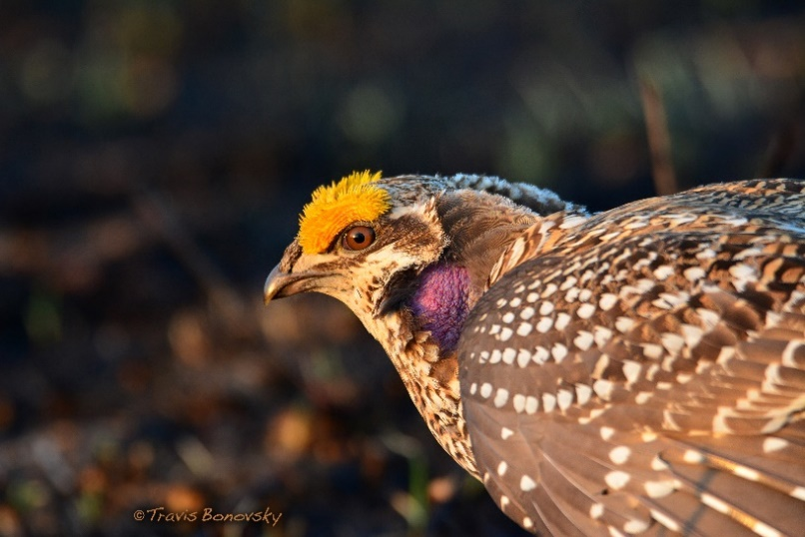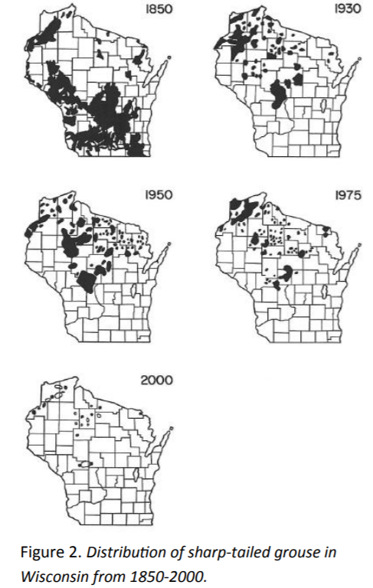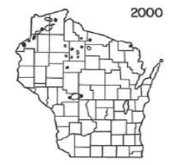

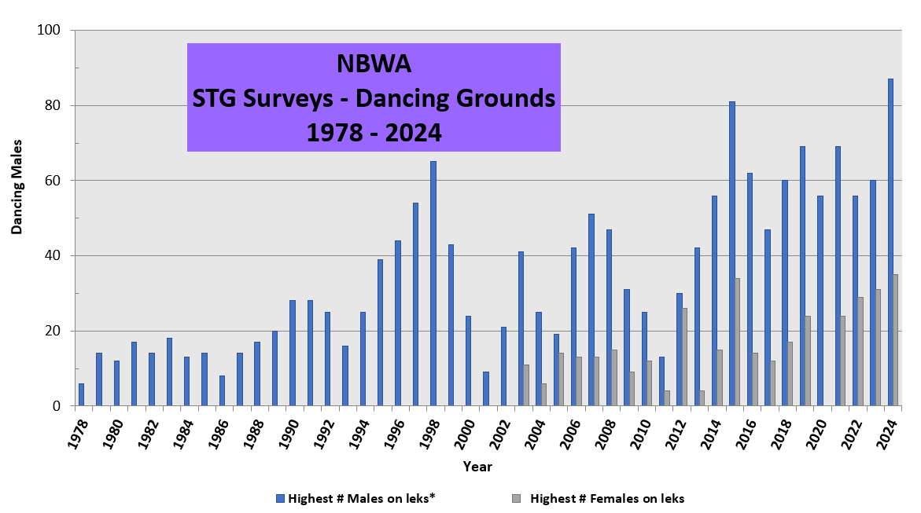

Recent Minnesota DNR research documented less mating behavior at leks when viewers arrived later or left earlier than recommended, compared to when people followed protocol. A**ll users must agree to this Protocol to reduce disturbances during mating and to keep viewing blinds open to the public.** **Only visitors that sign and agree can reserve a blind.**

**VIEWING PROTOCOL & PLEDGE**

* **Be in the blind at least 45 minutes before** [sunrise](https://sunrise-sunset.org/search?location=Namekagon+Barrens+Wildlife+Area), the earlier the better. Females are less likely to return when flushed after sunrise.
* **Remain in the blind until the birds have left at the end of the display period,** typically 2-3 hours. When birds are flushed by a predator and it is still early, they can return within a minute or several. Be quiet and move slowly while in the blind.
* When you leave, **gather your items, close the door and windows, and leave quickly and quietly** in case they wish to return to the lek.
* **Complete the survey and leave** it in the blind. Males display an orange eye comb and a violet throat patch when they dance. Females do not dance and lack the eye comb and throat patch.
* **Limit driving within the property; access via town roads and park by parking signs** to limit disturbances to other leks. For handicap access, contact Nancy Christel before reserving.

**My reservation party and I will follow the above protocol because we value healthy, sustained populations of sharp-tailed grouse and want to keep viewing blinds available.**

Users must agree to this Pledge when [reserving a blind](https://www.supersaas.com/schedule/FNBWA/Blind(s)).

**Expect Winter-Weather and Plan Appropriately**

Dress warm; bring a hot drink. In order to adhere to Protocol, wait to drink your liquids until you are in the blind and use the “bathroom” prior to entering the blinds. Properly dispose of toilet paper. **Outhouse available south of St. Croix just off of Gomulak at the cabin site.**

We recommend you locate the blind once during daylight prior to your reserved morning to help navigate in the dark. A small flashlight may help find the access location sign that reads STG Blind. Enter the blind through the zippered panel. Each blind contains small, padded seats and comfortably accommodates three adults. Don’t forget binoculars.

The best activity occurs when the sky is clear, winds are calm, and females are on the dancing ground. Rain and strong windy mornings limit lek activity.

Enjoy the show!

Nancy Christel (wildlife biologist) 715-645-0072

[](http://dnr.wi.gov/)

